Sample Statement on Origin

- For registered Exporter (export exceed 6,000 EUR)
(Invoice format depend on Exporter)

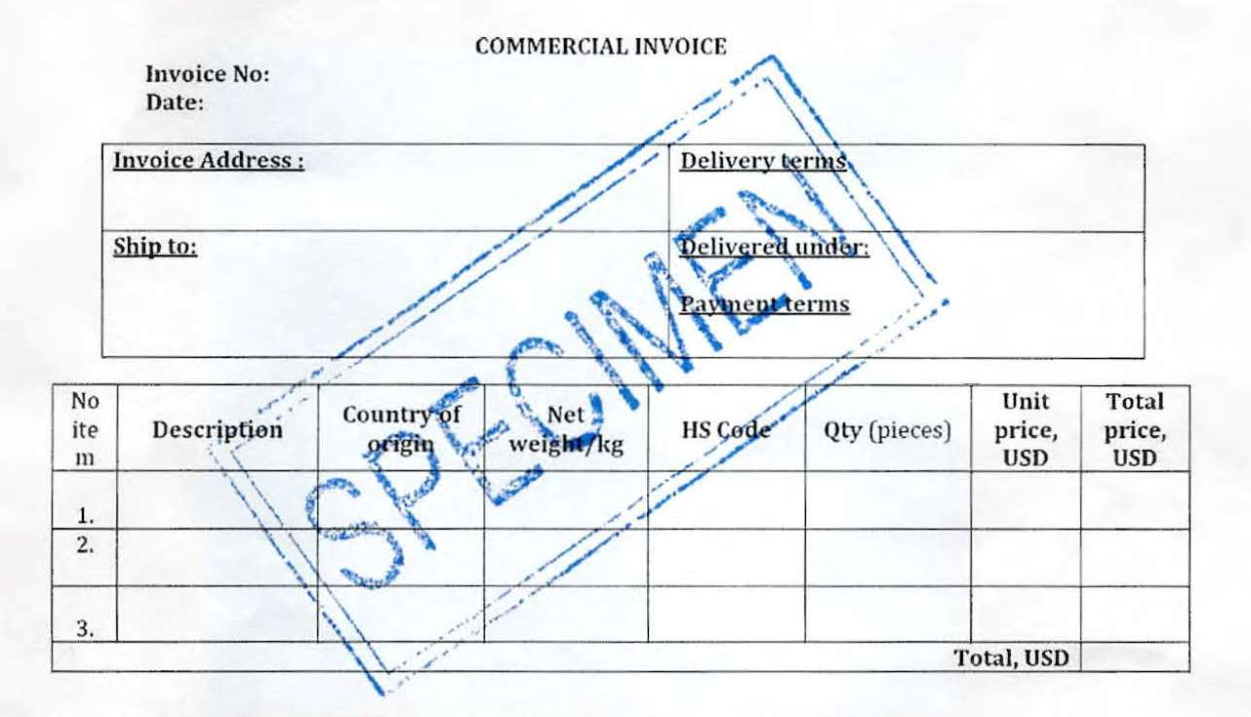
The exporter KHREX0123456789 of the products covered by this document declares that, except where otherwise clearly indicated, these products are of Kingdom of Cambodia preferential origin according to rules of origin of the Generalized System of Preferences of the European Union and that the origin criterion met is “W” 62.04.

Sample Statement on Origin

- For Exporter not yet Register or Registered (export under 6,000 EUR)
(Invoice format depend on Exporter)

The exporter of the products covered by this document declares that, except where otherwise clearly indicated, these products are of Kingdom of Cambodia preferential origin according to rules of origin of the Generalized System of Preferences of the European Union and that the origin criterion met is “W” 62.04.

